**JAWAN PAKISTAN**

**NAME :SYED OBAID ULLAH HASHMI**

**Roll NO:KWOWFL1165**

Assignment 3

**1. How to duplicate repeating items inside a Dart list?**

**Problem.**

**Consider the code:**

**final List<Ball> _ballList = [Ball (), Ball (), Ball (), Ball (), Ball (),]**

**What can to be done in order to not repeat Ball () multiple times?**

**CODE:**

void main() {

final _ballList = ["Ball" , "Ball" , "Ball" , "Ball" , "Ball" ,];

for (var i=0 ; i<_ballList.length-1;i++)

{

for (var j =i+1;j<_ballList.length;j++ )

{

if(_ballList[i]==_ballList[j])

{

print("The duplicate elements is :${_ballList[j]}");

}

}

}

}



**(2) How to get difference of lists in Dart? Problem: Consider you have two lists [1,2,3,4,5,6,7] and [3,5,6,7,9,10]. How would you get the difference as output? E.g. [1, 2, 4].**

CODE:

var list1= [1,2,3,4,5,6,7] ;

var list2= [3,5,6,7,9,10];

var list3= list1.toSet().difference(list2.toSet()).toList();

print(list3);

OUTPUT:

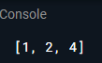

**3. Let’s say you are given a list saved in a variable:**

**Consider a = [1, 4, 9, 16, 25, 36, 49, 64, 81, 100].**

**Write a code that takes this list and makes a new list that has only the**

**even elements of this list in it.**

**CODE:**

//Q3

void main()

{

var a = [1, 4, 9, 16, 25, 36, 49, 64, 81, 100];

for (var b in a){

if(b%2==0){

print(b);

}

}

}

OUTPUT:

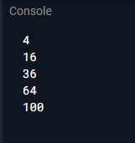

**4. Ask the user for a number and determine whether the number is**

**prime or not.s**

**CODE:**

**//Q4**

void main(){

print(" Enter Any numbers ");

int? n = int.parse(stdin.readLineSync()!);

if (n==1 || n==0 )

print("not prime numbers");

else

{

for (var i = 0; i<=n/2;i++)

if (n%i){

print("not prime numbers");

}

}

}

**5. Write a program to print multiplication table of 7 length 15.**

**CODE:**

//Q5

void main(){

print ("Table of 7");

print("___________");

for (var i =1; i <=15 ;i++)

{

var j=i*7 ;

print ("7 X ${i} = ${j}");

}

}

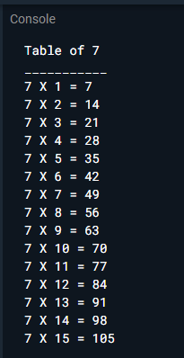

**6. Write a program to print items of the following array using for loop:**

**fruits = [“apple”, “banana”, “mango”, “orange” , “strawberry”].**

**CODE:**

**//Q6**

void main (){

var fruits = ["apple", "banana", "mango", "orange" , "strawberry"];

for (var i in fruits){

print (i);

}

**}**

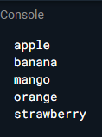

**7. Write a program to print multiples of 5 ranging 1 to 100.**

**CODE:**

//Q7

void main (){

print ("Multiples of five are as follows");

for (var i =1; i<=100;i++)

{

if (i%5==0)

print(i);

}

}

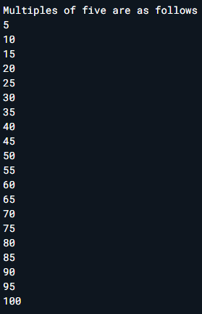

**8. The Temperature Converter: It’s hot out! Let’s make a converter**

**based on the steps here.**

**a. Store a Celsius temperature into a variable.**

**b. Convert it to Fahrenheit & output “NNoC is NNoF”.**

**c. Now store a Fahrenheit temperature into a variable.**

**d. Convert it to Celsius & output “NNoF is NNoC”.**

**CODE:**

//Q8

void main(){

var celsius_temperature=40;

double f = 40 * 1.8000 +32.00;

print ("celsius temperature to fahrenheit\ncelsius temperature= ${celsius_temperature} To fahrenheit = ${f}");

var fahrenheit = 35;

var c = 5/9 * (fahrenheit - 32) ;

print ("fahrenheit TO celsius");

print ("Celsius = ${c}");

}

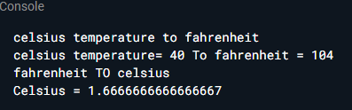

**9. Write a program to create a calculator for +, -, *, / & % using if**

**statements. Take the following input:**

**a. First number Second number**

**b. Operation (+, -, *, /, %)**

**Compute & show the calculated result to user.**

**CODE:**

//Q9

void main (){

var op;

double num1, num2;

print( "Enter operator: +, -, *, /: ");

double ? op = double.parse(stdin.readLineSync()!);

print("two numbers: ");

num1=46;

num2=50;

switch(op) {

case '+':

print ("${num1}+${num2} = ${num1+num2}" );

break;

case '-':

print ("${num1}-${num2} = ${num1-num2}" );

break;

case '*':

print ("${num1}*${num2} = ${num1*num2}" );

break;

case '/':

print ("${num1}/${num2} = ${num1/num2}" );

break;

default:

print( "Error! operator is not correct");

break;

}

}

**10. Write a program that takes a character (I. e. string of length 1)**

**and returns true if it is a vowel, false otherwise.**

**CODE:**

// Q10

void main()

{

bool lowercaseV,uppercaseV;

String c = "A";

lowercaseV = (c == 'a' || c == 'e' || c == 'i' || c == 'o' || c == 'u');

uppercaseV = (c == 'A' || c == 'E' || c == 'I' || c == 'O' || c == 'U');

if (lowercaseV || uppercaseV)

print ( " is a vowel.");

else

print( " is a consonant.");

}

